Weather Station
Part 2
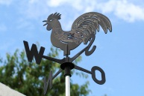

In the next step of the weather station project, you will need to create your own schematic or blue print of your station. From this diagram, you will create your own private home made weather station. The schematic must have the following parts:

- A paragraph explaining the purpose of your weather station, what it will measure and how you will use it. (Must be written in your own words!)
- Diagram of individual parts of the weather station and where they will be place in association to each other.
- The weather station must have the following instruments: thermometer, barometer, wind vane, anemometer, and rain gage.
- If you choose to use digital instruments for any part of the weather station you must give the source of your digital instrument or website.
- Provide scale of diagram ( can be computer generated)
- Label with straight lines or use a key for their diagram
- Properly cited references of any websites that are used in the construction of the station.

