Wind Instruments
Anemometer
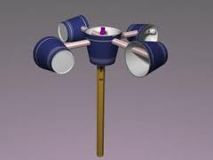
Materials:
5 cups
2 straws
Pencil
Can or bottle with sand

To Do:
- Poke a straw through the sides of four of the cups.
- Poke a pencil through the bottom of the fifth cup.
- Make sure all four cups are facing in the same direction.
- Push a cup through each end of a straw to create a pair. Do the same for the other straw and cups.
- Take a cup off at one end and push the straw through the center cup. Re-attach the cup. Do the same for the other straw and cups.
- Place the pencil in a can or bottle of sand to hold up your anemometer
- Mark a cup to make it identifiable. You will count this cup to determine wind speed. Ten turns per minute equals 1 mile per hour.

